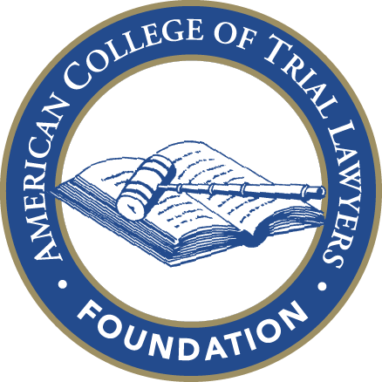
Foundation of the
American College of Trial Lawyers

Grant Application
Please submit your application to Amy Mrugalski at the ACTL National Office, amrugalski@actl.com. For questions, please call 949-752-1801.

The ACTL's U.S.Foundation provides up to approximately $800,000 in grants annually to law-related, non-profit organizations. The grants range in size from $10,000 to the $150,000 Emil Gumpert Award with most grants in the $20,000 to $50,000 range. The Foundation's principal purpose is to improve the administration of justice and, in particular, access to justice for underserved communities and individuals.

The ACTL Foundation welcomes grant applications for projects that are new and innovative and which may need start-up funds but which are expected to become self-sustaining. The Foundation favors projects that provide active legal assistance. The Foundation generally does not provide funds for general operating purposes, to support existing programs or to add new employees for existing programs.

- Date of Application:

- Name of Grant Applicant:

- Address of Grant Applicant:

- Principal Contact for Grant Applicant if different from No. 2:

- If Grant Applicant is other than an individual, please identify corporate or other organizational status, where incorporated or organized, and year of original incorporation/organization:

- If other than an individual, please describe the Grant Applicant's current status with state of incorporation or organization (i.e. active, authorized to do business, inactive, etc):

- If other than an individual, does the Grant Applicant hold any sort of tax exempt status such as 501(c)(3) corporation, etc? If so please explain.

- Does the grant applicant have a conflict of interest policy and procedure? If one exists, please attach a copy. Will a Fellow of the American College of Trial Lawyers be involved in the program/project? If so, who and what role will they play?

- What is the amount of the Grant requested?

- What is the purpose of the Grant requested? (Attach additional pages if you wish).

- Please provide an exact description of the program this Grant would support, or other purpose for this Grant request:

- Is this a startup or an existing program/purpose? If it is an existing program/purpose, when was it started?

- What important public need does this program/purpose serve?

- What is its primary goal with respect to maintaining or improving the administration of justice?

- How does it carry out its mission?

- How many people work for this program?

      - Paid staff

      - Volunteers

      - Interns for credit

f. What is the program's annual budget?

g. Will the Grant requested be sufficient to support the program/purpose for which the grant is being solicited? If not, how much additional money is necessary to carry out the program/purpose beyond any Grant made by the ACTL Foundation?

h. Will the program/purpose for which the grant is requested continue for more than a year? If so, what source of funding will be used to continue the program/purpose? If a Grant is awarded, does the Grant Applicant anticipate making the same or similar Grant Applications to the ACTL Foundation next year?

i. Does the Grant Applicant have or belong to a parent organization or program? If so, please identify that parent organization or program.

j. If awarded, how would this Grant be used? Please answer this question with as much detail as possible. (An important criterion for the ACTL Foundation is that its Grants be applied to specific projects or purposes. The Foundation does not look with favor on applications seeking funds for general purposes only; that is, to help the program accomplish its overall mission.)

k. Grant recipients will be requested to provide a written confirmation of the use of any grant and supply supporting information if requested. By submitting this grant request, do you agree to these terms?

l. Has this program/purpose received other Grants within the past 3 years? If so, from whom and in what amounts?

- Excluding answer 7(h) above, if different from the above program/purpose answers, what is the Grant Applicant's purpose and what are its primary goals?

- How does Grant Applicant carry out its purpose and primary goals?

b. How many people work for the Grant Applicant?

- Paid staff

- Volunteers

- Interns for credit

- What is the Grant Applicant's annual budget?

      - Please list the principal sources of that budget:

- Does the Grant Applicant have an annual report or its equivalent? If so, please attach a copy to this application.

